***1. Delete all PortForwarding***

- Delete all portforwardings in the VirtualBox

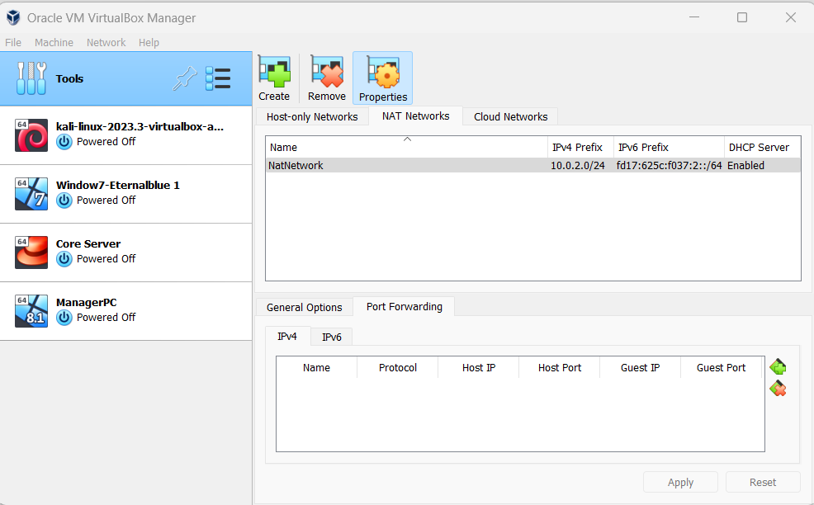

**2. Try to connect to DB server**

- Click Open

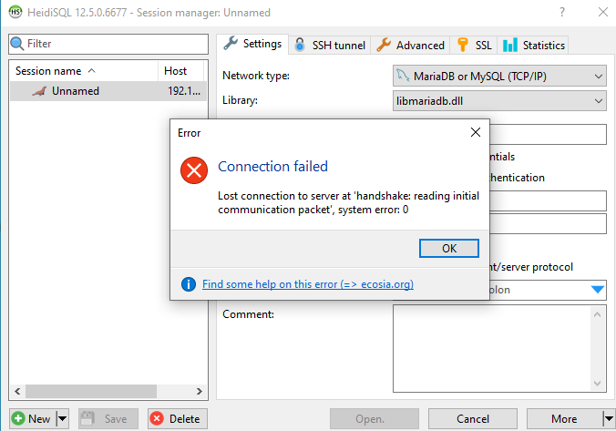

Connection Failed

**3. Make another route via Kali**

- make <Forward Tunnel> in your PC

Your PC> ssh -L 3306:localhost:8000 root@192.168.56.111

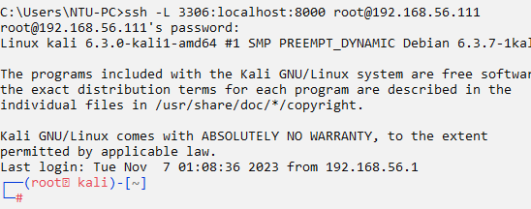

- make <Remote Tunnel> in Kali

Kali> ssh -R 8000:10.0.2.5:3306 root@192.168.56.111

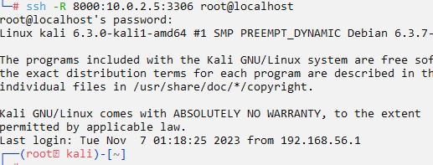

**4. Connect Again**

- Change connection address like this

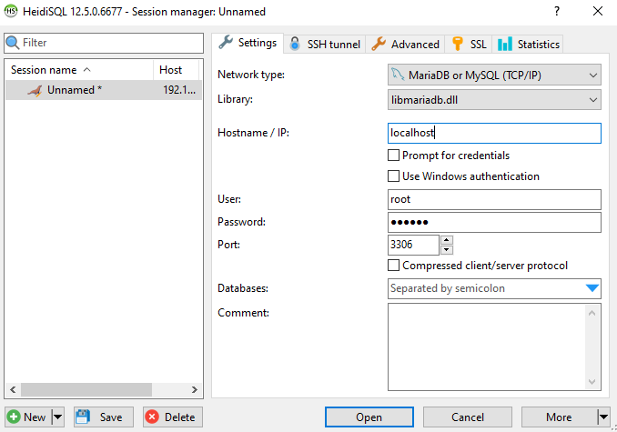

- Connect

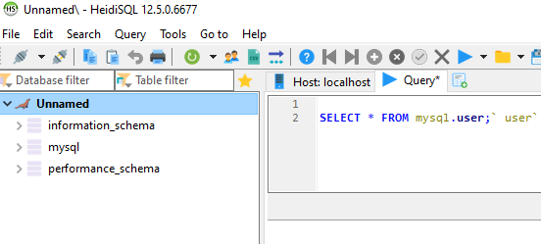

Win!!